ELIM COVENANT CHURCH
February 22, 2026
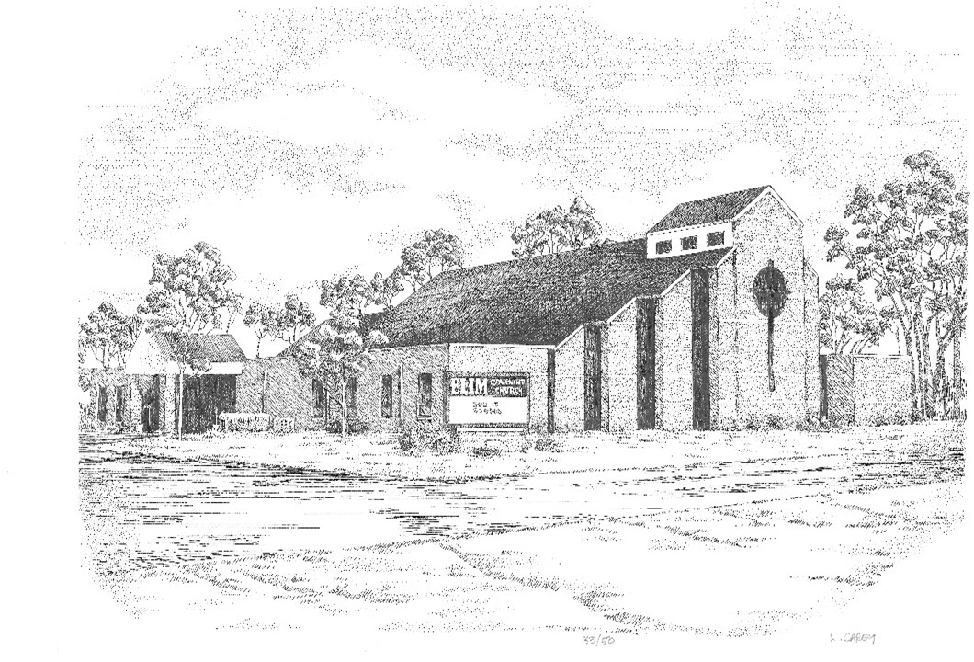

Elim Covenant Church
5201 18th Avenue
Moline, IL 61265
(309) 764-6920

Website: elimqc.org

Email Addresses
Pastor: pastor@elimqc.org
Church Office: office@elimqc.org

WORSHIP CELEBRATION
February 22, 2026
10:30 a.m.

Elim’s mission statement:
“To develop leaders who will impact the world for Christ.”

GATHERING BEFORE GOD

ANNOUNCEMENTS Don Peterson

OFFERING

MEMORY VERSE OF THE MONTH
“Set your minds on things above, not on earthly things”
(Colossians 3:2)

WORSHIP SONGS

WORDS FROM GOD

MESSAGE
“Principle Practices of a Disciple”
by Pastor Paul Hovey

PRAYERS OF THE PEOPLE

WORSHIP SONG

BENEDICTION

GREETERS TODAY Terry & Diane Snipes

Sermon Notes
Sunday, February 22, 2026
“Principle Practices of a Disciple”

Key Text: Be imitators of me, as I am of Christ. (1Co11:1)

Key Thought: Living the obedient Christian life requires us to develop our practice of several fundamental Christian disciplines: Bible engagement, prayer, biblical fellowship, and witnessing.

- Introduction

- A vibrant life in Christ is exemplified by:

-Hearing from God through His WORD (Ps1:1-2, 2Ti3:16, Ps19:7-10)

-Communing with God in PRAYER (Jn15:7, Ph4:6-7, Ex33:11)

-Engaging in deeper BIBLICAL FELLOWSHIP (Heb10:24-25, 1Jn1:3, 1Th2:10-12)

-Engaging in transformed MISSIONAL LIVING (Mt4:19, Rom1:16, 1Pe3:15-16)

3) Walking your walk (Jas1:22-25, Jn14:21, Rom12:1-2)

Questions for reflection:
-What is the difference between knowing about God and knowing Him personally? Which do you think you lean toward?
-What is one way you can begin living out your faith with ‘your team’ of fellow believers?
-Which spiritual practice is God calling you to deepen this week? What is the specific action you will take to make that happen? Who will you tell about your plans?

Looking Ahead
Sunday | February 22 | 9:15 a.m. | Sunday School
 |  | 10:30 a.m. | Worship Celebration Service
Tuesday | February 24 | 9:00 a.m. | “Amped” Prayer Meeting
 |  | 9:30 a.m. | SAS Bible Study
Thursday | February 26 | 9:30 a.m. | Keenagers
Saturday | February 28 | 9:00 a.m. | SPLASH
Sunday | March 1 | 9:15 a.m. | Sunday School
 |  | 10:30 a.m. | Worship Celebration Service
Tuesday | March 3 | 9:00 a.m. | “Amped” Prayer Meeting
 |  | 9:30 a.m. | SAS Bible Study
Sunday | March 8 | 12:00 noon | New Members’ Class
Wednesday | March 18 | 6:30 p.m. | New Members’ Class
February Birthdays
28 – Jessica Sandholm
March Birthdays
3 – Cheryl Bear 5 – Tammy Roach
9 – Sawyer Wood 12 – Marc Ellis
13 – Becky Reynolds 15 – Easton DeBroeck

March Anniversaries
1 – Daniel & Dori Cosgrove
3 – Teri Kay & Ramon Henderson
9 – Tom & Mary Dang

Attendance Last Week
Sunday Worship = 76/ Views on YouTube = 24
Sunday School/Children’s Church = 21

CHILDCARE SCHEDULE
TODAY, February 22
Children’s Church: Meagan Bear & Diane Snipes
Nursery: L.J. Cunningham & Kim Shuda
NEXT WEEK, March 1
Children’s Church: Kristen Burns & Rachel Cunningham
Nursery: Cheryl Bear & Elizabeth Peterson

