ELIM COVENANT CHURCH
August 13, 2023

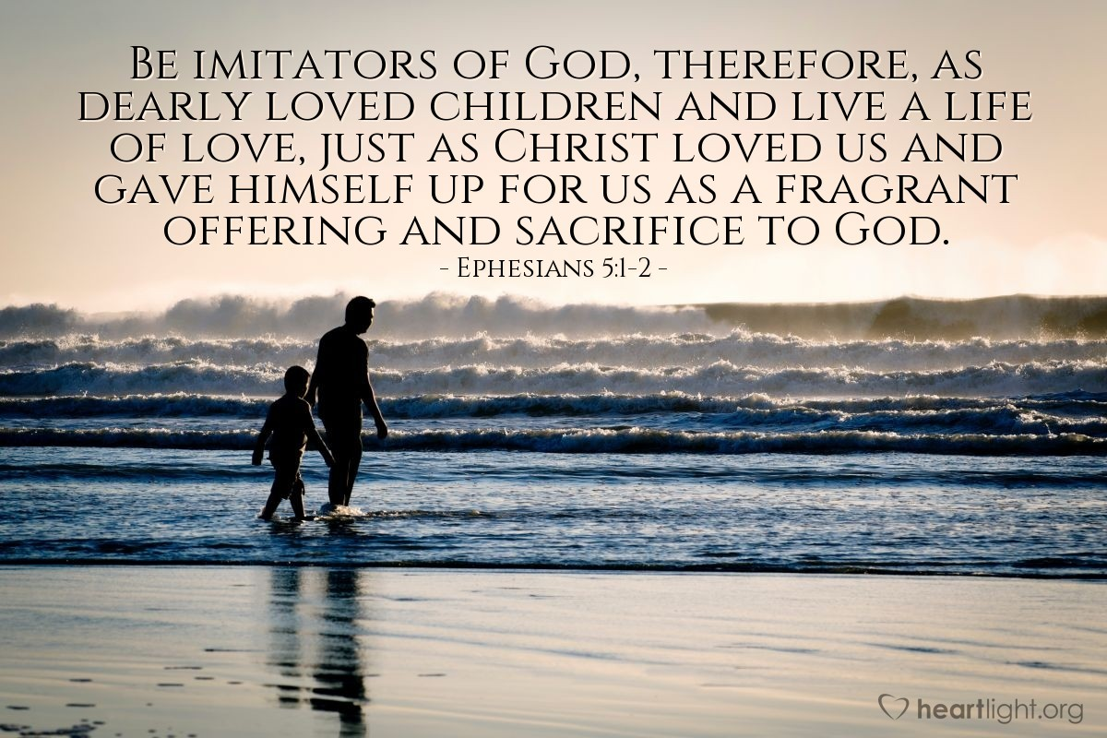

Elim Covenant Church
5201 18th Avenue, Moline, Illinois 61265
(309) 764-6920
Website: www.elimqc.org
Pastor’s e-mail: pastor@elimqc.org
Church office: office@elimqc.org

WORSHIP CELEBRATION
August 13, 2023
10:30 a.m.

Elim’s mission statement:
“To develop leaders who will impact the world for Christ.”

GATHERING BEFORE GOD

We are invited into the presence of God!

Please turn your cell phones off
The service is also being live-streamed and recorded for immediate or later viewing, and can be accessed at elimqc.org

ANNOUNCEMENTS Juanita Arellanos

OFFERING

MEMORY VERSE OF THE MONTH
“God opposes the proud, but gives grace to the humble.”
(James 4:6)

ADORATION TO GOD
We offer to God “a sacrifice of praise,” expressing our love and devotion to Him.

WORSHIP SONGS
“Build Your Kingdom Here”
“Day By Day”
“Take My Life and Let It Be”

HEARING FROM GOD
We give our attention to God by opening our lives to His Word! We invite God’s Spirit to take this Word into our lives that we might be formed
into the image and likeness of Jesus!

WORDS FROM GOD Ephesians 4:17-5:2

MESSAGE
“The Right Kind of ‘Tater”
by Pastor Steve Peterson

PRAYERS TO GOD

Now that God has spoken to us, it is time for us to speak to Him!

PRAYERS OF THE PEOPLE

BEING SENT BY GOD

God sends us out into the world that He passionately loves.

WORSHIP SONG
“I Will Follow”

BENEDICTION

Greeters Today: Mary Murphy and Karen Bowling

August Birthdays  14 – Orlin Johnson  18 – Jim Carsell  20 – Chris Carsell | August Birthdays  21 – Dewey Jacks  31 – Tabatha Estes
August Anniversaries
15 – L.J. and Rachel Cunningham
28 – Fran and Mary VanHooreweghe

Daily Bible Reading Guide 2023
God’s Saving Word: Unity in Christ Jesus
August 13 | 1 Thessalonians 2:17-3:13
August 14 | 1 Thessalonians 4:1-18
August 15 | 1 Thessalonians 5:1-28
August 16 | 2 Thessalonians 1:1-12
August 17 | 2 Thessalonians 2:1-17
August 18 | 2 Thessalonians 3:1-18
August 19 | 1 Timothy 1:1-20

Sermon Notes
Sunday, August 13, 2023
“The Right Kind of ‘Tater”
Ephesians 4:17-5:2

Prayer Page

Those in Need of God’s Strength and Healing:
Katie Clarke | Arlene Miller | Madeline Lumpkin
Don Neer | Wiley Barnes | Margaret Crandall
Tasha Munger | Felipe Cantu | JoAnn Nelsen
Gary and Julie Wells | Nathan Lyon | Sandy Winthurst
Jeff Parrott | Tabatha Estes
Families that have lost loved ones, caregivers, military families, and unspoken concerns.

Covenant Prayer Calendar — August 13 - August 19
Please pray for this week’s
Covenant missionaries and ministries:
Lisandro and Patty Restrepo (Mexico)  Syria and Lebanon  Africa  Robert and Rae Rife (Great Britain)  Jonathan and Faith Ro (East Asia) | Gary and Mary Lou Sander (Colombia)  Adrienne Low Satterberg and Ken Satterberg (France)  Joshua and Lori Shinar (Cameroon)

Prayer Opportunities

Prayer Cards: Feel free to use the prayer cards for your requests and drop them in the offering plate.

Prayer Following Worship: Elim Prayer Team is available to pray with you after the service in the Jeremiah classroom at the back of the sanctuary.

Prayer Gatherings: Wednesdays at 9:00 a.m. and 3:45 p.m. Come and pray with the team members and share your requests/praises.

Prayer Chain: Have a prayer need? Call Sandy at the church at (309) 764-6920 Monday thru Thursday 9:00 a.m. – 2:00 p.m. or call or text Sandy at (309) 592-7703 with your request.

SYMPATHY
Sympathy to the family of Curt Jackson upon his passing Sunday, August 6, 2023.

Hymn Sing
Sing to the Lord a new song! Or maybe even an old song but join us next this afternoon at 4:00 p.m. for our monthly hymn sing.

Be sure to invite your family and friends. Come and worship with us and enjoy a wonderful time worshipping God, good fellowship, and inspiration.

Haven’t tried it? Why not join us?

Elim Workday
Elim workday is scheduled for Saturday, August 26, at 8:00 a.m. There’s work inside and out. Whether you are 8 or 80+ or somewhere in between, there is something for everyone. Questions? See Don Yoeckel.

Birthday Wishes for Madeline Lumpkin
For those of you who have been around Elim Covenant Church a long time, you might remember Madeline Lumpkin. Madeline and her husband Harold moved to Missouri years ago, and Madeline and her family have kept in touch. Madeline’s 100th birthday is September 3. Her family will be celebrating and would like to hear from those who knew her.

You can send your photos, messages, memories, and birthday wishes to her granddaughter, Tammy Hagler, who will collect them and create a photo book. You can send them to her at 245 Elim Street, Forsyth, Missouri 65653 or email them to Garren Lumpkin at hglumpkin@hotmail. Please have your responses in by August 25. Thank you!

Outdoor Movie Night
On Saturday, August 19, at 8:00 p.m. we are having an outdoor movie night. Mark your calendar and stay tuned for more details.

Elim Family Night
Sundays, 5:30-7:00pm
Beginning Sunday, September 10, we are kicking off our new Sunday evening programming for all ages! We'll start off with an evening meal, then have times for worship, study, prayer, games and FUN!! Come one and come all!

But, God is Good
Save the date! This year’s women’s retreat will take place September 15, 16, and 17 at Covenant Harbor located in Lake Geneva, Wisconsin. Each year there is a raffle for various types of baskets. The funds collected help finance future retreats. The churches of each district are asked to donate two baskets to raffle off. There is a box for donations on the table in the gathering area. Thanks!

The “Loss of a Spouse” seminar is Tuesday, August 29, 2023, at 6:00 p.m. GriefShare begins the following Tuesday, September 5 at 6:00 p.m.
There are sign-up sheets and information on the table in the gathering area. If you know of someone who is grieving, please pass this information on to them. Many have been helped and life-long friendships have been made from these two programs.

Looking Ahead
Sunday | August 13 | 9:15 a.m. | Sunday School
 |  | 10:30 a.m. | Worship Celebration Service
 |  | 6:00 p.m. | Hymn Sing
Tuesday | August 15 | 9:30 a.m. | SAS Bible Study
 |  | 11:00 a.m. | Daytime Trivia
Wednesday | August 16 | 9:00 a.m. | “AMPED” Prayer Meeting
 |  | 10:00 a.m. | Mats for the Homeless
 |  | 3:45 p.m. | Prayer Meeting
Thursday | August 17 | 6:00 p.m. | MLT Meeting
Saturday | August 19 | 8:00 p.m. | Outdoor Movie Night
Sunday | August 20 | 9:15 a.m. | Sunday School
 |  | 10:30 a.m. | Worship Celebration Service

Attendance Last Week
Sunday Worship = 66 Views on YouTube = 21
Sunday School/Children’s Church = 19

MOWING SCHEDULE
August 19 Jim Nelson and Mike Hermann
August 26 Tom Lancial and L.J. Cunningham

CHILD CARE SCHEDULE

TODAY, August 13:
Children’s Church: Elizabeth Peterson and Kim Shuda
Nursery: Meagan Bear and Mariah Richardson

NEXT WEEK, August 20:
Children’s Church: Amy Hennings and Kristen Burns
Nursery: Sandy McNeal and Karen Bagatelas

Christian Care Immediate Needs
Bottled Water, #10 Cans of Veggies
Canned Fruit, Ground Coffee
Large Bottles of Shampoo
Large Bottles of Conditioner
Body Wash

